Causal Analysis and Resolution Guidelines



Revision History

Version Number | Creation/  Revision Date | Prepared /Updated By | Reviewed By | Approved By | Change Description
1.0 | 13.07.2023 | Rajashree M. | Jayanta C. | Jayanta C. | Baseline the process

Table of Contents
1) Defect Resolution Plan 3
2) Identify and Analyze Causes 3
2.1) Requirements 3
2.2) Design 4
2.3) Coding & Unit Testing 4
2.4) System Integration Testing 5
2.5) Documentation 5
3) Defect Classification 6
4) Defect Cause Resolution 7
5) Defect Resolution & Causal Analysis Meetings 8
5.1) Defect Resolution Meeting 8
5.2) Causal Analysis Meetings 9
5.3) Preventive Actions 9
5.4) Evaluation of the Effectiveness of Defect Preventive Actions 10
5.5) Causal Analysis Report 10
5.6) Causal Analysis Method 13
5.6.1) Cause-and-Effect Diagram 13
5.6.2) 5 WHY’s 22
6) Organization Level Defect Resolution 23

Defect Resolution Plan

Project Owner / Development Owner shall plan for Defect Resolution activities within the project as part of the project planning. This shall include:

- Identification of Defect Resolution team
- Schedule and frequency of Defect Resolution meetings
- Plans for Defect Resolution actions
- Frequency and criteria for effectiveness evaluation of Defect Resolution actions

Identify and Analyze Causes
Assigning Defect Type to defects

- During defect analysis, a defect is to be classified into one of the defect types.
- The defect type is an attribute of a defect indicating the kind of error that was made or the nature of correction needed to fix the defect. By assigning a defect type to each defect, we can see which the most prevalent type of defects is. Once this is identified we can then examine why these type of defects occur and plan preventive actions for the same.
- Type is assigned to a defect typically in the defect resolution stage after the exact defect has been identified. Here it is essential to understand the difference between a defect in a work product and it’s Symptom. A defect symptom is as seen during testing, e.g. the software gives a runtime error when the menu option save is selected.
- A defect is an error in work product which caused the software to malfunction, e.g. in the previous example it could be non-initializing of a pointer variable which might have led to the runtime error. So it is important to identify the defect in the work product and classify it rather than try to classify the Symptom of the defect.
- In the above example the same manifestation could have been due to a defect that the return value of a function allocating memory was not checked for error condition. As we can see the same runtime error could occur because of either an error checking defect or a pointer initialization defect.
- Once we identify and assign the defect type, it is easy to proceed with causal analysis and Defect Resolution. E.g. if it is seen that most of the defects are of Logic type, then specific causes for the same can be identified and preventive actions planned

Requirements

Defect | Cause
Lack of clarity on requirements | No common understanding between Onsite Coordinator / Channel partner and Off Shore tech team.
 | Lack of expertise of channel partners
 | Acceptance criteria not clear/ not properly documented
Rework | Client /Channel Partner delays for Sign off and Clarifications.
 | “Cut Off Time” for Sign Off and Clarifications is not negotiated.
 | Processes and Document Templates to be followed are not negotiated by both the parties
Improper assumptions | Lack of technical and domain knowledge
Not able to Capture Implicit requirements | Lack of domain knowledge
Improper Error/Successful Messages | Lack of domain knowledge

Design

Defect | Cause
Design documents are not updated to Reflect Changes | Schedule Pressure
Unable to come up with a good Architecture | Project is divided into phases.
Unable to do-good design and Good review of design docs | Lack of skill set
No proper design | Coding and Design is done by the same person
Design is not addressing Non Functional requirements | Not following Design Guidelines
Non-Functional requirements Are not traced in design | Not following Traceability Guidelines

Coding & Unit Testing

Defect | Cause
No input validations | Developer not referring to the design & requirements docs.
(GUI, Database, Libraries, HTML) | Lack of understanding
 | No low level design
 | Design and Code are loosely coupled
 | No exception/error handling in LLDD
 | No pseudo code
Spending lot of time on code reviews | No clear understanding of coding Standards.
No Clear distinction  Between Logging vs. Throwing Exceptions | Not addressed in Design
No Proper Exception Handling | Not addressed in Design
 | Code reviews not done
 | Design errors migrating to code
Memory leakage | Not following good programming guidelines
 | Code reviews not done
 | Unit testing not done
 | No effective code reviews done
GUI Errors | Resolution problems
 | Skill set mismatch
 | GUI reviews not done
 | Not following GUI standards & guidelines
 | No proper GUI design available
Code (API) documentation | Developers are reluctant to document
Not knowing / coding for non-functional requirements | No clear non-functional requirements
 | Not having right tools
 | Not knowing or capturing technology requirements

System Integration Testing

Defect | Cause
Ineffective testing | Inadequate system understanding
 | Unclear SRS
 | SRS not updated with changes
 | Test activities not planned
 | Missing test specification
 | Wrong or missing test design method
 | Defect finding activity not completely executed
 | Insufficient test environment
 | Insufficient test data
 | Test plan not updated with changes
 | Error in analyzing test results
 | No proper interaction between test & dev teams
 | Unable to simulate the bugs next time
Test Engineers are not involved in the
Project from the beginning
 | System is not tested under deployment environment
 | Requirements and Design Documents are not updated to reflect changes.
 | Schedule pressure
 | Lack of training

Documentation

Defect | Cause
Average Quality Documents | Technical writers are not allocated
 | Developers documenting user docs not proficient in English
 | Lack of technical and domain knowledge by the writer

Defect Classification
Defect - A defect is what was wrong or incorrect in the work product
Cause - A cause is some preceding incident that brought about the defect

Defect Classification
Phase | Defect Type | Phase Defect Code
RequirementsrE  Req | Incomplete Requirement | IC
 | Incorrect Requirement | CR
 | Ambiguous Requirement | AR
 | Inconsistent Requirement | IR
 | Traceability Error | TE
 | Labeling Error | LE
 | Use case representation /description | UE
 | Incorrect Internal Cross Reference | II
Design | Documentation Standards | DS
 | Logic | LO
 | Maintainability | MN
 | Details Missing | DM
 | Effective | EF
 | Functionality | FN
 | User Friendliness | UF
 | Language/Prose | LN
 | Portability | PT
 | Flexibility | MD
 | Consistency | IN
 | Integrity | IT
 | Security | SC
CUT | Code Comments | CC
 | Change History | HS
 | Logic | LO
 | Maintainability | MN
 | Performance | PE
 | Redundancy | RD
 | Coding Standards | CS
 | Data Initialization | DI
 | Data Area Management | DA
 | Interface With Other Programs | IF
 | Test & Branch | TB
 | Boundary | BN
 | Structured ness | ST
SIT | Interface Capability | IC
 | Interface Specification | IS
 | Interface Description | ID
 | Interface Usability | IU
 | Missing Design | MD
 | Functional Specification | FS
 | Performance Errors | PE
 | Checking | CG
 | Missing Implementation | MI
 | Run Time Error | RE
 | Logical Error | CE
 | GUI Error | UI
 | Build Error | BE
 | Not Clear | NC
 | Incomplete Data | ID
 | Not Traceable | NT
 | Redundant | RD
 | Style | ST
 | Build Error | BE
Deployment | Environment Issue | EI

Defect Cause Resolution

Phase | Defect Type | Phase Defect Code | Preventives
Requirements | Incomplete Requirement | IC
 | Incorrect Requirement | CR
 | Ambiguous Requirement | AR
 | Inconsistent Requirement | IR
 | Traceability Error | TE
 | Labeling Error | LE
 | Use case representation /description | UE
 | Incorrect Internal Cross Reference | II
Design | Documentation Standards | DS
 | Logic | LO
 | Maintainability | MN
 | Details Missing | DM
 | Effective | EF
 | Functionality | FN
 | User Friendliness | UF
 | Language/Prose | LN
 | Portability | PT
 | Modularity | MD
 | Consistency | IN
 | Integrity | IT
 | Security | SC
Code | Code Comment | CC
 | Change History | HS
 | Logic | LO
 | Maintainability | MN
 | Performance | PE
 | Redundancy | RD
 | Coding Standards | CS
 | Data Initialisation | DI
 | Data Area Management | DA
 | Interface With Other Programs | IF
 | Test & Branch | TB
 | Boundary | BN
 | Structuredness | ST
SIT | Incomplete Data | ID
 | Not Traceable | NT
 | Redundant | R
 | Style | S
Deployment | Environment | EI

Defect Resolution & Causal Analysis Meetings

Defect Resolution Meeting

Defect Resolution Meeting is conducted as per the schedule given in the Defect Resolution plan. A team consisting of Lead and identified team members conducts the Defect Resolution Meeting.

Prior to the Defect Resolution Meeting the Lead consolidates all the defect data for the project. This includes data for defects detected after the previous Defect Resolution Meeting (CAM) if any. The inputs for this meeting are:

- Defect data as recorded during review, inspection and testing
- Pareto Analysis of the defect causes

Based on the Pareto Analysis of the defect causes, major cause(s) of defects are identified. For the Identified major cause(s) Cause/Effect (Fishbone or Ishikawa) diagram may be used to identify the specific sub-causes. Defect Resolution actions for these causes are identified. The team shall

- Prioritize all action items based on the various factors such as ease of implementing the action, benefit resulting from the action, future plans etc.
- Prepare an implementation plan for the action items.
- Review the progress of action plan items from previous meetings.

Causal Analysis Meetings
- The causal analysis meetings should be held at a frequency, which will provide maximum benefit to the project. The right time is when sufficient data is available for analysis and identifying preventive actions.
- For a project of short duration where phases are short, causal analysis meeting may be held at every phase end. When the phases are of long duration, it is recommended that Defect Resolution meeting may be held as soon as sufficient defect data is available. It is recommended that a causal analysis meeting be held when data is available for about 25 defects.
- For maintenance projects, the recommended frequency for the causal analysis meetings is monthly.

Causal analysis is conducted using the cause-and-effect diagram technique. All the relevant team members should participate in the causal analysis of defects. The recommended practice is that causal analysis be conducted based on defect types. For each defect type (identified for causal analysis) a separate Cause-and-effect diagram shall be constructed.

Preventive Actions
Based on the outcome of the causal analysis, actions should be suggested to prevent recurrence of the defects.
Some of the typical suggestive actions for each of the defined cause categories are as follows:
- Group meetings
- Improving informal information sharing
- Tools to automate notifications
- Distribution of notes on important changes/developments in the project
- Use of checklists
- Common error lists
- Improved documentation on the process, application and standards
- Inspections of the work products
- Enhancement of test cases
- Adequate documentation on the application
- Guidelines
- Classes, seminars, project specific training (application/technical)
- Formal screening and induction of new team members.
- Inspection/review of the work products at all the phases.
- Process improvements
- Training on the processes, refresher courses on the processes, training kit on the processes
A database of successful defect preventive actions implemented in past projects is maintained as part of the Project Knowledge Base in Qualify.
At the beginning of the project, the PO may refer to this database to identify the potential causes of defects and the successfully implemented preventive actions in similar projects. Throughout the project life-cycle, the PO may refer to this database to identify effective defect preventive actions.
Once appropriate defect preventive actions are determined, PO shall disseminate the information to all the team members and ensure implementation of the same, primarily during the task kick-off meetings.

Evaluation of the Effectiveness of Defect Preventive Actions

Effectiveness of the defect preventive actions is to be evaluated based on the metrics. Some of the indicators of an effective defect preventive action are:

- Reduction in total number of defects
- Reduction in number of defects attributed to the cause for which preventive action has been taken
- Reduction in percentage of defects attributed to the cause category for which preventive action has been taken
- Reduction in rework effort
- Reduction in review / testing effort

After the defect preventive actions are implemented, the DR Coordinator should look at some of the metrics mentioned above to evaluate the effectiveness of the defect preventive action

Causal Analysis Report
    - Defect Type Wise Data Sheet

Definition: A chart that depicts the Defect types their count and the weights and the percentages of weights.

Purpose: To draw the Pareto diagram

Guidelines to Calculate Weighted Defects
- From the Peer Review report count the number of defects and put the count as shown below under respective severity heads and defect type. Refer to the legend below for the description of the ODC defects.
- Calculated the weighted defects for each defect type. Each severity is associated with a weight.
The weights for each severity are as below

Blocker – 5
Critical - 3
Major – 2
Minor – 1
Trivial – 0

Ex: The weighted defects for defect type A is 5 * 5(Number of defects * Severity weight age.)

- Calculate Percentage as (Weighted defects for each defect type * 100)/Total Weighted Defects (80)

Ex: For defect type A the weighted defects is 25 and the total weighted defects is 80 so percentage is (25*100)/80 which is equal to 31.25%.

Defect Type | A | B | C | D | F | G | I | T | Total Weighted Defects
Severity Level
Blocker | 5 |  |  |  |  |  |  |  | -
Critical |  | 5 |  |  |  | 5 |  |  | -
Major |  |  | 5 |  |  |  | 5 |  | -
Minor |  |  |  | 5
Trivial |  |  |  |  | 5 |  |  | 5
Weighted. Defects | 25 | 15 | 10 | 5 | 0 | 15 | 10 | 0 | 80
Percentage | 31.25 | 18.75 | 12.5 | 6.25 | 0 | 18.75 | 12.5 | 0 | 100.00

Defect Type | Description
A | Assignment
B | Build
C | Checking
D | Documentation
F | Function
G | Algorithm
I | Interface
T | Timing/Serialization

    - Pareto Diagram

Pareto Principle states that only a "vital few" factors are responsible for producing most of the problems. This principle can be applied to quality improvement to the extent that a great majority of problems (80%) are produced by a few key causes (20%). If we correct these few key causes, we will have a greater probability of success

Definition: A bar graph used to arrange information in such a way that priorities for process improvement can be established.

Purpose: To prioritize defects.

Pareto Diagram:

Take the defect type and the weighted defects from the Defect type wise data sheet and arrange in the descending order of weighted defects for each defect type as below.

Defect Type | Weighted Defects | Cumulative Percentage
A | 25 | 25
G | 25 | 50
B | 12.5 | 62.5
F | 12.5 | 75
I | 12.5 | 87.5
C | 6.25 | 93.75
D | 6.25 | 100

- Draw a Pareto diagram as below with defect types on the X – Axis and the weighted defects on the Y-Axis.
- Plot the points in the graph for the cumulative percentages as depicted in the graph and draw a line connecting the points.

- Here in the above table the cumulative percentage is the sum of first cumulative percentage and the next weighted defect. The first cumulative percentage becomes 25 + 0 = 25. Next cumulative percentage becomes 25 + 25, which is 50; the third is 50 + 12.5 = 62.5 and so on.

- The red dots in the graph indicate the “cumulative percent”

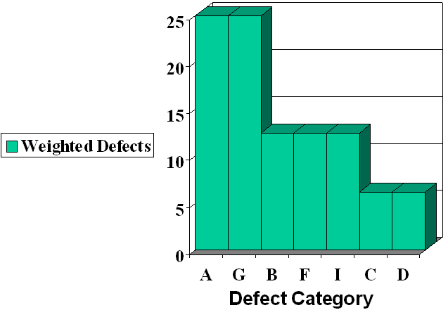

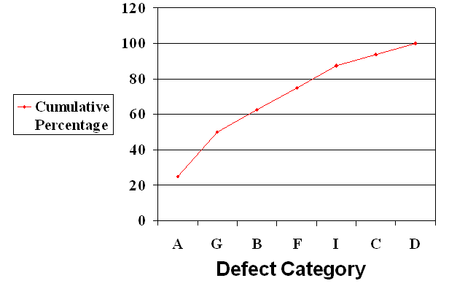

The above graph helps to decide on which defects to be considered for Defect Resolution first, here it can be inferred that the defects of type A and G form the vital few to be considered for Defect Resolution activities as the major defects come under these defect categories.

    - Cause Effect (Fishbone Diagram)

Definition: The Cause & Effect (CE) diagram, also sometimes called the ‘fishbone’ diagram, is a tool for discovering all the possible causes for a particular effect.

Purpose: To identify the root cause of the defects.

Causal Analysis Method

Cause-and-Effect Diagram
The recommended method for conducting causal analysis is Cause & Effect Diagram with Brainstorming. This method is also known as Fishbone or Ishikawa diagram. This is a generic method used to identify root causes of all the problems / defects encountered.
A Cause-and-Effect Diagram is a tool that helps identify, sort, and display possible causes of a specific problem or quality characteristic. It graphically illustrates the relationship between a given outcome and all the factors that influence the outcome. This type of diagram is sometimes called an "Ishikawa diagram" because it was invented by Kaoru Ishikawa, or a "fishbone diagram" because of the way it looks.

When should a team use a Cause-And-Effect Diagram?
Constructing a Cause-and-Effect Diagram can help your team when you need to
- Identify the possible root causes, the basic reasons, for a specific effect, problem, or condition
- Sort out and relate some of the interactions among the factors affecting a particular process or effect.
- Analyze existing problems so that corrective action can be taken.

Why should we use a Cause-and-Effect Diagram?
A Cause-and-Effect Diagram is a tool that is useful for identifying and organizing the known or possible causes of quality, or the lack of it. The structure provided by the diagram helps team members think in a very systematic way. Some of the benefits of constructing a Cause-and-Effect Diagram are that it:
- Helps determine the root causes of a problem or quality characteristic using a structured approach.
- Encourages group participation and utilizes group knowledge of the process
- Uses an orderly, easy-to-read format to diagram cause-and-effect relationships
- Indicates possible causes of variation in a process
- Increases knowledge of the process by helping everyone to learn more about the factors at work and how they relate
- Identifies areas where data should be collected for further study

Example:-1

Guidelines to Construct Fish Bone:
- Select the defects from Pareto to identify the causes.
- Attribute the defects to People, Process, Tools, Inputs and Outputs
- Under each identify the possible causes.
- How to draw a CE diagram?

Step 1

- Write down the ultimate effect caused because of the defects to be investigated and draw the 'backbone' arrow to it. In the example shown below the effect is 'Incorrect deliveries'

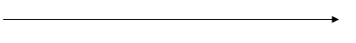

Step 2

- Draw five branches off the large arrow to represent People, Process, Tools, Inputs and outputs

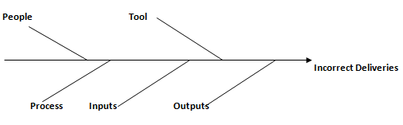

- Any sub-causes can be branched on the main causes as shown below

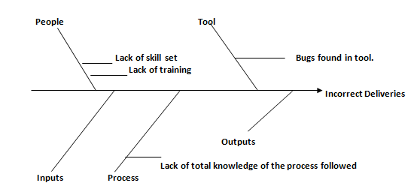

In the Cause and effect diagram given above the main cause(s) for incorrect deliverables are attributed to:

  - People
  - Process and
  - Tool.

From the above cause and effect diagram it can be inferred that the root cause for incorrect deliverables can be:

- People involved, lack the necessary skill set required to deliver the correct requirement
- The tool(s) used has bugs which has resulted in “incorrect deliverables”
- The process followed is not clearly understood across the team.

Example:-2

How do we develop a Cause-and-Effect Diagram?
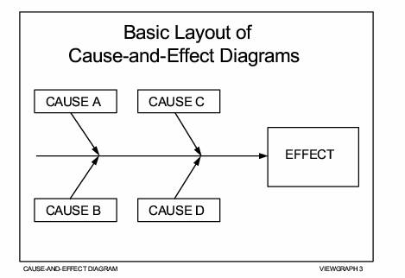
When you develop a Cause-and-Effect Diagram, you are constructing a structured, pictorial display of a list of causes organized to show their relationship to a specific effect. The following figure shows the basic layout of a Cause-and-Effect Diagram. Notice that the diagram has a cause side and an effect side. The steps for constructing and analyzing
a Cause-and-Effect Diagram are outlined below.

Step 1 - Identify and clearly define the outcome or EFFECT to be analyzed
- Decide on the effect to be examined. Effects are stated as particular quality characteristics, problems resulting from work, planning objectives, and the like.
- Use Operational Definitions. Develop an Operational Definition of the effect to ensure that it is clearly understood.
- Remember, an effect may be positive (an objective) or negative (a problem), depending upon the issue that’s being discussed.
- Using a positive effect which focuses on a desired outcome tends to foster pride and ownership over productive areas. This may lead to an upbeat atmosphere that encourages the participation of the group. When possible, it is preferable to phrase the effect in positive terms.
- Focusing on a negative effect can sidetrack the team into justifying why the problem occurred and placing blame. However, it is sometimes easier for a team to focus on what causes a problem than what causes an excellent outcome. While you should be cautious about the fallout that can result from focusing on a negative effect, getting a team to concentrate on things that can go wrong may foster a more relaxed atmosphere and sometimes enhances group participation.
You must decide which approach will work best with your group.
The steps in constructing Cause-and-effect diagram will be illustrated using an example. In this example, causes relating to a car's poor gas mileage are identified.
Step 2 - Using a chart positioned so that everyone can see it, draw the SPINE and create the EFFECT box.
- Draw a horizontal arrow pointing to the right. This is the spine.
- To the right of the arrow, write a brief description of the effect or outcome which results from the process.
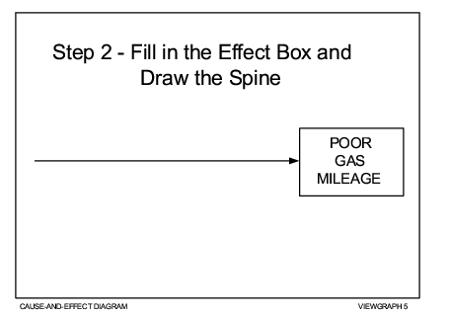
Draw a box around the description of the effect.
EXAMPLE: The EFFECT is Poor Gas Mileage. See figure below

Step 3 - Identify the main CAUSES contributing to the effect being studied.
- These are the labels for the major branches of your diagram and become categories under which to list the many causes related to those categories.
- Establish the main causes, or categories, under which other possible causes will be listed. You should use category labels that make sense for the diagram you are creating. Here are some commonly used categories:
    - 3Ms and P - methods, materials, machinery, and people
    - 4Ps - policies, procedures, people, and plant
    - Environment - a potentially significant fifth category
    - Any category that suits the diagram such as Process, Project, Software, System, Hardware, Network, Engineering, Support, etc.
- Write the main categories your team has selected to the left of the effect box, some above the spine and some below it.
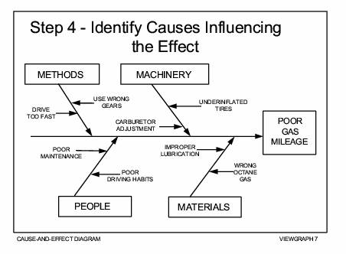
- Draw a box around each category label and use a diagonal line to form a branch connecting the box to the spine.
EXAMPLE: Below figure uses the 3Ms and P to start developing the diagram we began in Step 2.

Step 4 - For each major branch, identify other specific factors which may be the CAUSES of the EFFECT
- Identify as many causes or factors as possible and attach them as sub-branches of the major branches.
- Fill in detail for each cause. If a minor cause applies to more than one major cause, list it under both.


EXAMPLE: The possible CAUSES for Poor Gas Mileage are listed under the appropriate categories in the figure

Step 5 - Identify increasingly more detailed levels of causes and continue organizing them under related causes or categories.
You can do this by asking a series of why questions.
EXAMPLE: We’ll use a series of why questions to fill in the detailed levels for one of the causes listed under each of the main categories.
Q: Why was the driver USING THE WRONG GEAR?
A: The driver couldn't hear the engine.
Q: Why couldn't the driver hear the engine?
A: The radio was too loud.
A: Poor hearing
Q: Why were the TIRES UNDERINFLATED?
A: No record of tire pressure
A: Difficult air stems
Q: Why were the air stems difficult?
A: Poor design
Q: Why was MAINTENANCE POOR?
A: Lack of money
A: No awareness
Q: Why was WRONG OCTANE GAS used?
A: Didn’t know recommended octane
Q: Why wasn’t recommended octane known?
A: No owner's manual
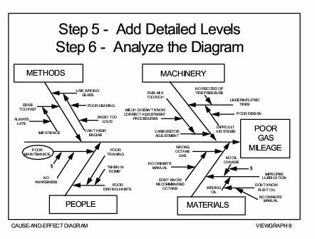
The figure below shows how the diagram looks when all the contributing causes that were identified by the series of why questions have been filled in. As you can see, there may be many levels of causes contributing to the effect.
NOTE: You may need to break your diagram into smaller diagrams if one branch has too many sub branches. Any main cause (3Ms and P, 4Ps, or a category you have named) can be reworded into an effect.

Step 6 - Analyze the diagram.
Analysis helps you identify causes that warrant further investigation. Since Cause-and-Effect Diagrams identify only possible causes, you may want to use a Pareto Chart to help your team determine the cause to focus on first.
- Look at the “balance” of your diagram, checking for comparable levels of detail for most of the categories.
- A thick cluster of items in one area may indicate a need for further study.
- A main category having only a few specific causes may indicate a need for further identification of causes.
- If several major branches have only a few sub-branches, you may need to combine them under a single category.
- Look for causes that appear repeatedly. These may represent root causes.
- Look for what you can measure in each cause so you can quantify the effects of any changes you make.
- Most importantly, identify and circle the causes that you can take action on.

EXAMPLE: Let's analyze the diagram we have been constructing.
- The level of detail is pretty well balanced.
- No causes are repeated.
- Poor Maintenance appears to be a cause for which you could develop measurements.
- Moreover, Poor Maintenance appears to be a cause that you can take action on. It is circled in the figure above to earmark it for further investigation.

More Examples of Cause-and-effect diagrams
Here are a few more examples of Cause-and-effect diagrams.
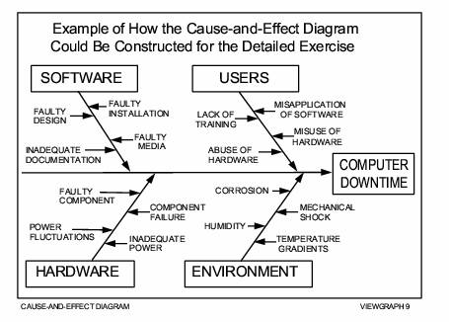

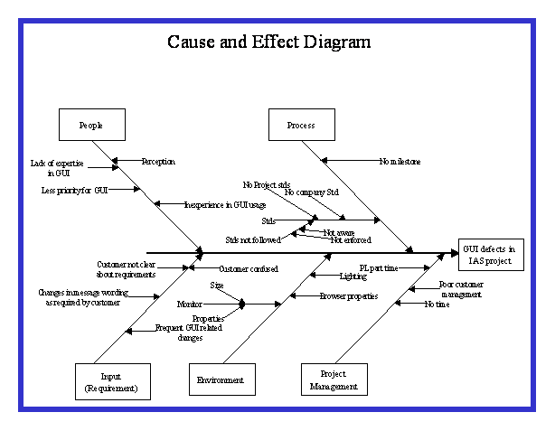

5 WHY’s

Five Why’s Preparation

Five why’s is a Root Cause Analysis Tool. Not a problem solving technique. The outcome of a 5 Why’s analysis is one or several root causes that ultimately identify the reason why a problem was originated. There are other similar tools as the ones mentioned below that can be used simultaneously with the 5 Why’s to enhance the thought process and analysis.
Corrective
Actions
Problem
Root Cause

Root Cause analysis Tools:
- Ishikawa Charts (Fish Bone)
- Design of Experiments
- Is / Is not Analysis
- 5 Why’s
- Cause & Effect Diagram.
- Statistical Data Analysis (Cpk , Paretto Charts, Anova, etc…)

- Any 5 Why’s must address two different problems at the same time. The first part is related to the process that made the defective part.
(“Why made?”)
- The second one must address the detection system that was not able to detect the defective part before it became a problem. The lack of detection of a defective product is a problem of its own and must be treated independently than the product problem itself.
(“Why not detected?”)

- Even though the discipline is called 5 Why’s is not always necessary to reach 5 before the root cause of a problem is fully explained; or it may take more than 5 why’s to get to the bottom of it. It will depend on the complexity of the process or the problem itself.
- In any case, 5 have been determined, as a rule of thumb, as the number at which most root causes are clearly identified. Do not worry about not meeting or exceeding this number though. Just follow your thought process and let it decide how many Why’s you require to get to the point where the root cause is evident.
- For all the Five Why’s:
Ask the full question including the problem or cause behind it.
If there is a problem with labeling ask:
“Why the parts were labeled incorrectly?”
If the answer is unreliable database ask:
“Why is the database unreliable?”

- It is said that a well-defined problem is a half resolved problem; hence it is important to state the problem as clearly as possible.
- Whenever possible define the problem in terms of the requirements that are not being met. This will add a reference to the condition that should be and is not.

Organization Level Defect Resolution
- The Defect Resolution data along with the successfully implemented action plans from the projects is submitted to DR Council and SEPG.
- DR Council and SEPG collates inputs on Defect Resolution from projects and conducts a periodical Organization Level Defection Meeting, (preferably once in 3 months).
This data shall include:
- Pareto Analysis of defect causes
- Cause/Effect Diagrams
- 5 WHY Analysis
- Defect Resolution Action Plan
- Defect Resolution meeting may also be held on an event driven basis.
- A Pareto analysis based on cause category of defects detected across organization will be performed to identify the prime cause of defects across organization.
- This along with other Defect Resolution data obtained from projects will be analyzed to identify organization-wide defect preventive actions.
- These actions may contain process enhancements.
- SEPG also maintains the Organization Level defect preventive action database as part of the project knowledge base.
- SEPG identifies the effective defect preventive actions taken in projects and makes them available as part of this database for the reference to the Leads for implementation in the projects
- Revisions (if any) to the organization's set of standard process resulting from Defect Resolution actions are incorporated as per document control procedure

